**Word Search**

***Crypto***

**Challenge:**

Can you find the hidden flag?

Attached - WuLUG_Word_Search_2023.zip

**Approach:**

The way I solved it, definitely not the way it was supposed to be solved.

Am I proud of it? Definitely! It was a blind shot and i wasn’t expecting to find it, until i did lol

How did I do it? My method :) Opening files on notepad!

First we unzip the file and we get a .docx file “*WuLUG Word Search 2023.docx”*

We look in it and there’s a crossword puzzle in there. I don’t have much knowledge about .docx files so I switched to my notepad-methodology.

We unzip the .docx file (Confused? Yeah these files can be unzipped as well, google about it, it’s crazy awesome!) and get the various folders and files. Rest all was brute force from here. Opening every file and looking for the flag prefix: *“CaptureTheWu”* using the grep command, we finally got it inside word > document.xml

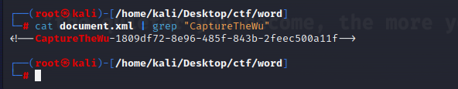

**Flag: CaptureTheWu-1809df72-8e96-485f-843b-2feec500a11f**

Congrats!!

Happy Hacking!